**QSMART – TRIGGER CARD REPLACEMENT**

**PROCEDURE**

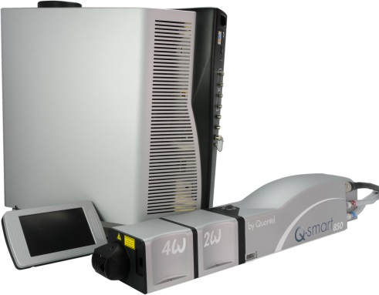

**Toolkit:**

Allen Keys

**System**: QSMART

|  |  |  |  |  |  |  |
| --- | --- | --- | --- | --- | --- | --- |
| |  |  | | --- | --- | | **SM010352** | **Q-SMART TRIGGER CCA ASSY** | |  |  |  |  |

**Purpose**: This document details how to change the TRIGGER Card

|  |  |  |
| --- | --- | --- |
| Revision | date | modification |
| Initial issue | July 4, 2014 |  |
|  |  |  |
|  |  |  |
|  |  |  |

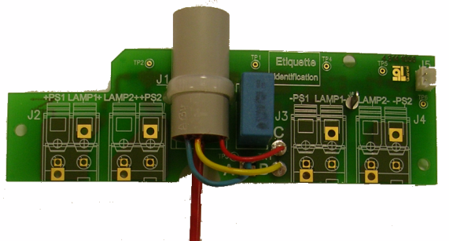

# DISASSEMBLING

* Turn the system off
* Disconnect cables and water hoses from the side of the laser head
* Remove the laser head cover.
* Unscrew the CHC 3x6 screw + ZU3 washer holding the trigger card wire

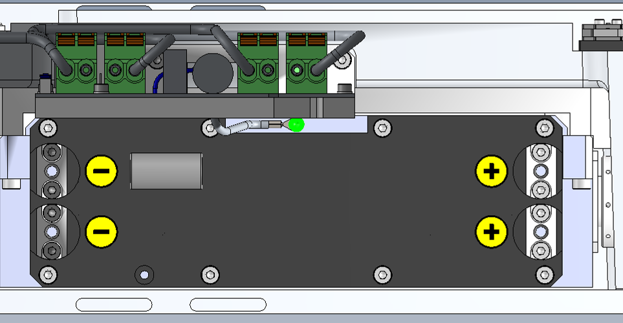

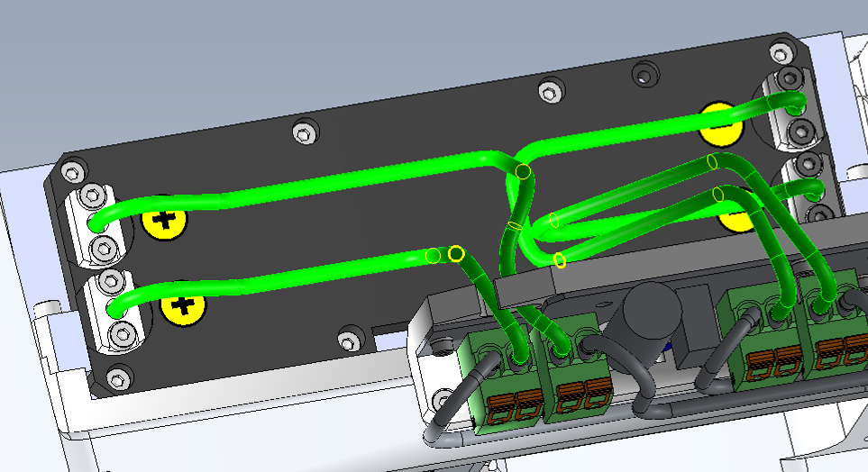

* Disconnect the flash cables from the Trigger card.

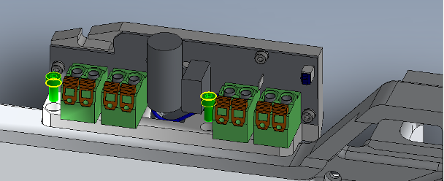

* Unscrew the 2 4x10 HCC screws holding the unit

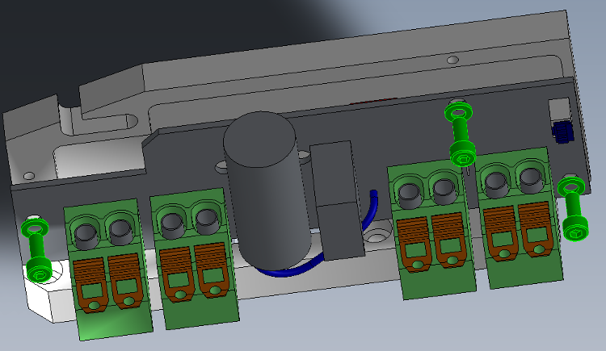

* Remove the TRIGGER card 4/300/1056 from its 3/PLA/1267 support (3 CHC M3x8 screws + 3 ZU3 washers)

# IMPLEMENTATION OF THE TRIGGER CARD

|  |  |  |
| --- | --- | --- |
| 1.00 | 4/300/1056 | TRIGGER CARD MOD EQUIPED |
| 3.00 | V/CHC-M0308A4 | CHC3X8 SCREW |
| 2.00 | V/CHC-M0410A4 | CHC4X10 SCREW |
| 3.00 | R-ZU--D03--A2 | ZU3 WASHER |



* Fasten the TRIGGER card 4/300/1056 to its 3/PLA/1267 support (3 CHC M3x8 screws + 3 ZU3 washers)



* Fasten the unit to the foundry (2 4x10 HCC screws)

Connect the wires as shown

* 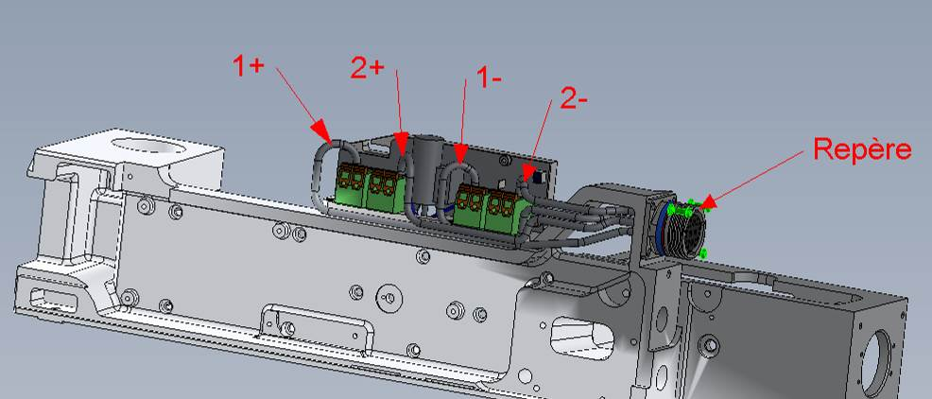Connect the flash wires like shown.



* Connect the flash cables to the TRIGGER card
* Fasten the TRGGER card wire like shown (CHC 3x6 screw + ZU3 washer)



* Close the Laser head and put warranty stickers   
  *Refer to "LH-Warranty Labels"*